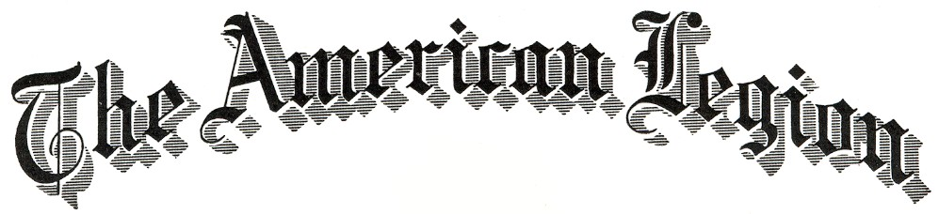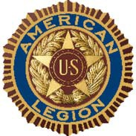

Certificate of Appreciation

This certificate of appreciation is gratefully presented to
Recipient
In recognition and sincere appreciation of service and fulfilling the duties of Judge at the 2024 2nd Division Oratorical Contest which contributed to the advancement of The American Legion and activities dedicated to God and Country.

Presented by Presentor, Title, Organization, Oratorical Chair
This ___ Day of Month, Year

ATTEST:

